Ideation Phase
Define the Problem Statements

Date | 22 June 2026
Team ID
Project Name | Student Leave Request Management
Maximum Marks | 2 Marks

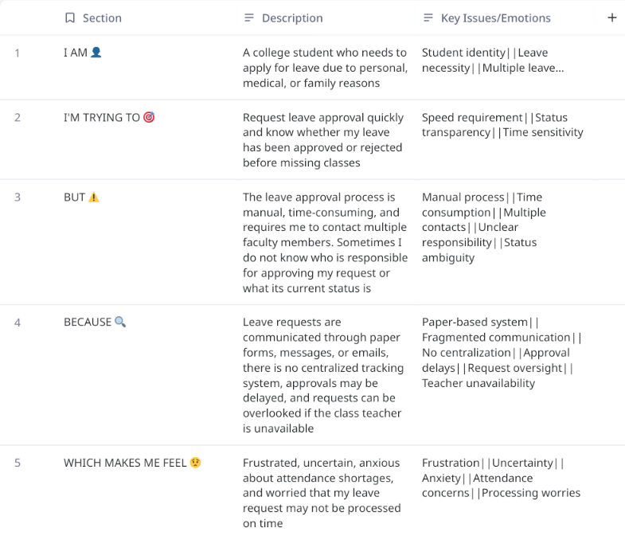
Reference: https://miro.com/templates/customer-problem-statement/
Problem Statement (PS) | I am (Customer) | I’m trying to | But | Because | Which makes me feel
PS-1 | A Student | Get my leave applications sorted out for my personal/medical reasons. | It is a very long process starting from paperwork making its way through the hierarchy. | Faculty/HOD’s aren’t always available, and they have their own schedules. | Tense, Annoyed, Unsure about my permissions.
PS-2 | Class Teacher | Complete all my duties on time for the students and others. | It also requires me personally signing their attendance letters. | Other faculty cannot directly award attendance without my consent at least. | Disappointed because I could not attend to the needy students.

